1. Daniel Libeskind
1.1 Career
1.2 Studio works
2. Hani Rashid
2.1 Asymptote
2.2 Projects
2.2.1 Installations & Exhibitions
2.2.3 Awards

1. Daniel Libeskind

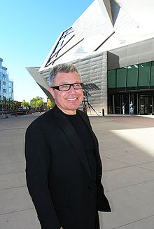

1.1 Personal life

Born in Postwar Poland, Libeskind immigrated to America with his family becoming an American citizen in 1964. He studied music in Israel (on the America-Israel Cultural Foundation Scholarship) and in New York, and became a virtuoso performer. He left music to study architecture, receiving his professional architectural degree in 1970 from the Cooper Union for the Advancement of Science and Art in New York City. He received a postgraduate degree in History and Theory of Architecture at the School of Comparative Studies at Essex University (England) in 1972.

Since establishing his practice in Berlin in 1989, Mr. Libeskind has designed major cultural, commercial and residential projects around the world. These include the master plan for the World Trade Center and the Jewish Museum Berlin. In October of 2011, his firm, Studio Daniel Libeskind, completed its redesign of what is now Germany’s largest museum, the Military History Museum in Dresden. The same month Hong Kong’s City University celebrated the opening of the Libeskind-designed Run Run Shaw Creative Media Centre. Other recent projects include the Grand Canal Theatre project, a major addition to Dublin’s docklands and the city’s cultural core; Crystals at CityCenter, a 500,000-square-foot retail complex that is the centerpiece of MGM Mirage’s signature development on the Las Vegas Strip.

The Studio has several projects under construction, including City Life’s redevelopment of the historic Fiera Milano Fairgrounds in Milan; Kö-Bogen, an office and retail complex in Düsseldorf; two high-rise developments, The L Tower in Toronto and Reflections at Keppel Bay, a two-million-square-foot residential development in Singapore; Zlota 44, a residential high rise in Warsaw; and Haeundae Udong Hyundai l’Park, a mixed-use development in Busan, South Korea, which when completed, will include the tallest residential building in Asia.

Projects in development include Archipelago 21, the master site plan for the Yongsan International Business District in Seoul; the Institute for Democracy & Conflict Resolution, for the University of Essex in England; Vitra, a residential tower in Sao Paulo, Brazil; and the Central Deck and Arena in Tampere, Finland, a mixed-used development that contains an ice hockey arena large enough to seat 11.000 visitors.

Among the many Libeskind buildings that have received worldwide acclaim are The Felix Nussbaum Haus, in Osnabrück, Germany (1998); the Imperial War Museum North in Manchester, England (2002); the extension to the Denver Art Museum and the Denver Art Museum Residences (2006), the Royal Ontario Museum (2007) and the Glass Courtyard, an extension to the Jewish Museum Berlin,(2007); the Ascent at Roebling’s Bridge, a residential high-rise in Covington, Kentucky (2008); the Contemporary Jewish Museum in San Francisco (2008); and Westside, Europe’s largest retail and health center, located in Bern, Switzerland (2008).

Daniel Libeskind Mr. Libeskind has taught and lectured at many universities worldwide. He has held such positions as the Frank O. Gehry Chair at the University of Toronto, Professor at the Hochschule für Gestaltung, Karlsruhe, Germany, the Cret Chair at the University of Pennsylvania, and the Louis Kahn Chair at Yale University. He has received numerous awards including the 2001 Hiroshima Art Prize — an award given to an artist whose work promotes international understanding and peace, never before given to an architect. Mr. Libeskind’s ideas have influenced a new generation of architects and those interested in the future development of cities and culture.

1.2 Career

Though he had been an architectural theorist and professor for many years, Libeskind completed his first building at the age of 52, with the opening of the Felix Nussbaum Haus in 1998. Prior to this, critics had dismissed his designs as "unbuildable or unduly assertive." The first design competition that Libeskind won was in 1987 for housing in West Berlin, but soon thereafter the Berlin Wall fell and the project was canceled. Libeskind won the first four projects he entered into competition for.

The Ascent at Roebling's Bridge, Covington, Kentucky
The Jewish Museum Berlin, completed in 1999, was Libeskind's first major international success and was one of the first buildings designed after reunification. Libeskind has also designed cultural and commercial institutions, museums, concert halls, convention centers, universities, residences, hotels, and shopping centers. Critics often describe Libeskind's work as deconstructivist.

Libeskind is perhaps most famous for being selected by the Lower Manhattan Development Corporation to oversee the rebuilding of the World Trade Center, which was destroyed in the September 11, 2001 attacks. He titled his concept for the site Memory Foundations.
Studio Daniel Libeskind, headquartered two blocks south of the World Trade Center site in New York, is currently working on over 40 projects across the world. The studio's most recent completed projects include the Contemporary Jewish Museum in San Francisco, California, The Ascent at Roebling's Bridge in Covington, Kentucky, and the Royal Ontario Museum in Toronto, Ontario.

In addition to his architectural projects, Libeskind also designs opera sets for productions such as the Norwegian National Theatre's The Architect in 1998 and Saarländisches Staatstheater's Tristan und Isolde in 2001. He also designed the sets and costumes for Intolleranza by Luigi Nono and for a production of Messiaen's Saint Francis of Assisi by Deutsche Oper Berlin. He has also written free verse prose, included in his book Fishing from the Pavement.

1989–1999 Jewish Museum Berlin – Berlin, Germany
1995–1998 Felix Nussbaum Haus – Osnabrück, Germany
1997–2001 Imperial War Museum North – Greater Manchester, England
1998–2008 Contemporary Jewish Museum – San Francisco, California, United States
2000–2003 Studio Weil – Majorca, Spain
2000–2006 Extension to the Denver Art Museum, Frederic C. Hamilton Building – Denver, Colorado, United States
2000–2006 Denver Art Museum Residences – Denver, Colorado, United States
2000–2008 Westside Shopping and Leisure Centre – Bern, Switzerland
2001–2003 Danish Jewish Museum – Copenhagen, Denmark
2001–2004 London Metropolitan University Graduate Centre – London, England
2001–2005 The Wohl Centre – Bar-Ilan University, Ramat-Gan, Israel
2002–2007 Michael Lee-Chin Crystal, extension to Royal Ontario Museum and renovation of ten of its existing galleries - Toronto, Ontario, Canada
2003–2005 Tangent, Facade for Hyundai Development Corporation Headquarters – Seoul, South Korea
2004–2005 Memoria e Luce, 9/11 Memorial – Padua, Italy
2004–2007 Glass Courtyard addition to the Jewish Museum Berlin – Berlin, Germany
2004–2008 The Ascent at Roebling's Bridge, residential condominium building – Covington, Kentucky, United States
2005–2009 MGM Mirage's CityCenter, retail and public space on the Las Vegas Strip – Paradise, Nevada
2004–2010 Grand Canal Square, Grand Canal Theatre and Commercial Development – Dublin, Republic of Ireland
2010 Wheel of Conscience monument, M.S. St. Louis Memorial, Pier 21 – Halifax, Canada
2001–2011 Military History Museum – Dresden, Germany
2002–2011 Run Run Shaw Creative Media Centre – Hong Kong
2006–2011 Reflections at Keppel Bay, high-rise and low-rise villa apartment blocks – Keppel Bay, Singapore
2007-2011 Haeundae I Park Marina, skyscraper complex – Busan, South Korea
Under construction
2003–2014 One World Trade Center – New York City, New York
2005–2012 Złota 44, apartment tower – Warsaw, Poland
2005–2011 L Tower and Sony Centre for the Performing Arts Redevelopment – Toronto, Canada
2009–2014 Kö-Bogen, Königsallee, Düsseldorf, Germany
Proposed/In Design
2004–2010 New Center for Arts and Culture - Boston, Massachusetts, United States
2004–2014 CityLife (Milan) – Milan, Italy
2005–? Edwards Condominiums, urban infill residential and commercial spaces – Edwards, Colorado, United States
2006–? Ørestad Downtown Master Plan, urban development – just south of Copenhagen, Denmark
2006–? Rejuvenation, Forest Heights Boys and Girls Club – Gulfport, Mississippi, United States
2006–2011 Haeundae Udong Hyundai I'Park, five waterfront towers – Busan, South Korea
2006–2013 New Songdo City, shopping mall, department store, cinema, ice rink, food court in Riverstone complex – Incheon, South Korea
2004–2010 Editoriale Bresciana Tower, 23-story office and luxury apartment building – Brescia, Italy
2007–2009 18.36.54, residence – Connecticut, United States
2010–2013 Tampere Central Arena – Tampere, Finland
2011–2015 Beth Shalom, liberal Synagogue – Munich, Germany
2011–2015 Convention Center of Mons, Belgium.

1.2.1 Studio works

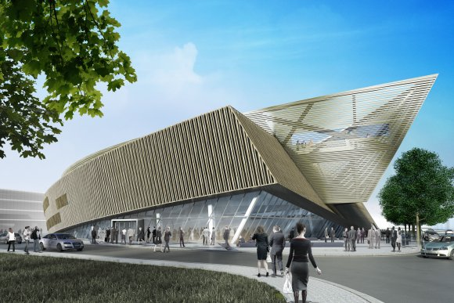  Centre De Congrès À Mons  Mons, Belgium | 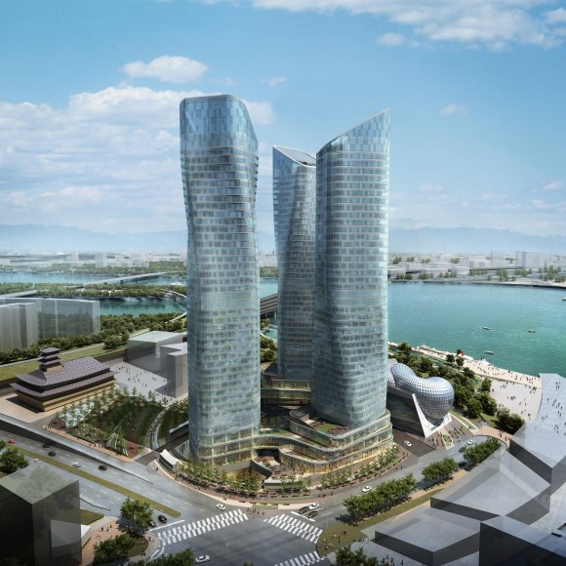  Dancing Towers  Seoul, South Korea
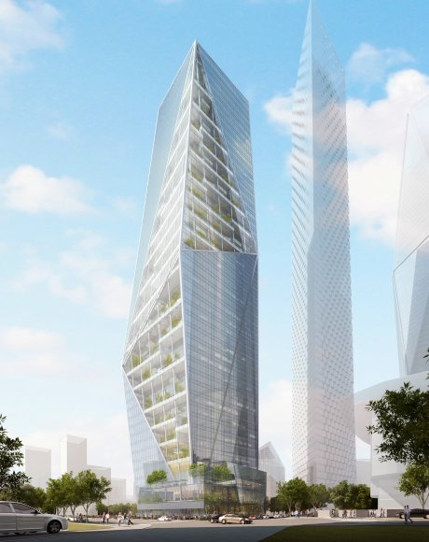
Harmony Tower
Seoul, South Korea
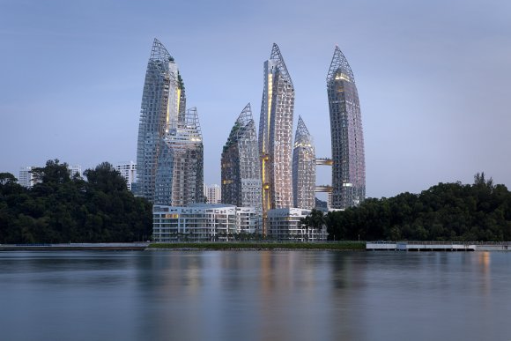
Reflections at Keppel Bay
Keppel Bay, Singapore

2. Hani Rashid

Hani Rashid (* 1958 in Cairo) is a principal and founder of Asymptote Architecture. Rashid co-founded the New York based architecture practice with his partner, Lise Anne Couture, in 1989.
In 1983 Rashid received his bachelor's degree in architecture from Carleton University (Canada) and in 1985 received a Master of Architecture degree from the Cranbrook Academy of Art in Bloomfield Hills, Michigan. Rashid's academic career includes visiting professorships at several universities, including the Royal Danish Academy of Fine Arts in Copenhagen, the Southern California Institute of Architecture (SCI-Arc) in Los Angeles, the Harvard University Graduate School of Design, the Berlage Institute in Amsterdam, the University of Michigan (Ann Arbor) and the Lund University. Since 1989, Rashid has been an Associate Professor of Architecture at the Graduate School of Architecture, Planning and Preservation at Columbia University in New York, where he launched the "Advanced Digital Design" (1992) and the "Digital Design Initiative" (1995). In 2004, he received a professorship at the Cátedra Luis Barragán in Monterrey, Mexico and from 2006- 2009 he was a professor at the Swiss Federal Institute of Technology in Zurich. In 2008, Rashid was the recipient of the Kenzo Tange Visiting Professor Chair at the Harvard University Graduate School of Design. He was also a member of the jury for the Aga Khan Award for Architecture. From 2009 to 2011 he was a guest professor at the School of Architecture at Princeton University.

In 2000 Rashid represented the U.S. at the Seventh International Architecture Biennale in Venice, Italy. In 2004, Asymptote Architecture was selected as the design architects of Metamorph, the Ninth Venice Architecture Biennale.

Asymptote Architecture was awarded the prestigious Frederick Kiesler Prize for Architecture and the Arts in recognition of exceptional contributions to the progress and merging of art and architecture.

Since its inception in 1989, Asymptote has received awards for visionary building construction, master planning, art installations, exhibitions, product design as well as spatial landmark for digital environments. Since October 2011 Rashid has been a professor at the University of Applied Arts Vienna.
Architectural work

Rashid's work as principal of Asymptote includes among others 166 Perry Street, a luxury residential building in Manhattan's Westvillage, the Yas Viceroy Abu Dhabi Hotel a luxury hotel and one of the main architectural features of the new Yas Marina development and accompanying Formula 1 raceway circuit in Abu Dhabi and the HydraPier Pavilion in Haarlemameer the Netherlands.

Asymptote's Portfolio also includes some high-profile interior work such as the New York Stock Exchange Advanced Trading Floor, the American flagship stores for Carlos Miele and Alessi and the Carlos Miele Store in Paris.

Other projects include the winning entry for the World Business Center Solomon Tower in Busan, South Korea in 2007, a large-scale cultural, hotel and performing arts complex in Penang, Malaysia and the Strata Tower in Abu Dhabi.

2.1 Asymptote

2.2 Projects

1989 Asymptote won international recognition for their winning entry of the Steel Cloud in the Los Angeles Westcoast Gateway Competition. In 1992, Lise Anne Couture and Hani Rashid were asked by The New York Times to design a hypothetical building for Times Square.
In 1996, Asymptote built their first project overseas,the Universe Theatre in Aarhus, Denmark. The project was awarded the Danish building of the year award by the Architects' Association of Denmark. In 1999,Asymptote designed the first large capacity virtual reality environment and also completed the Advanced Floor Operations Center on the trading floor of the Wall Street facility.

The project was listed in the AIA Guide to Noteworthy Architecture in New York City.
In 2003 the firm won the AIA New York Chapter Design Award, Architecture Category for their Design of the HydraPier Pavilion in Haarlemmermeer,Netherlands.

In 2003 Asymptote finished the American flagship store for Carlos Miele. Three years later they built the AlessiFlagship Store.[5][6] Both projects won the AIA NY Chapter Interior Architecture Award. In 2006 the second Carlos Miele Store opened it's doors in Paris.

In November 2009 the firm completed theYas Viceroy Abu Dhabi Hotel in Abu Dhabi,United Arab Emirates and in early 2010 166 Perry Street a luxury residential building in Manhattan's West Village was completed.

Other projects include 190 Váci Commercial Towers in Budapest, Hungary, the FCD Yongsan Landmark Tower in Seoul, South Korea, a design for the Zurich Circle, Zurich,Switzerland, the Strata Tower an innovative, forty-story, luxury residential tower in Abu Dhabi,United Arab Emirates, a large-scale cultural, hotel and performing arts complex in Penang, Malaysiaand a commission to build the World Business Center Busan in Busan, South Korea. The design for the World Business Center Busan consists of three separate, tapered towers "soaring" out of a single base and will, upon completion, will be among the tallest buildings in Asia at 560m.

2011 Asymptote Architecture won second place in the 'Kaohsiung Port Terminal 2010' competition, featuring a sculptural design for the Kaohsiung Port Terminal in Taiwan.Another project from 2011 was the Beukonhof, an auditorium / crematorium in the city of Schiedam, Netherlands.

In June 2012 Asymptote announced the launch of the Velo Towers, part of the Dreamhub development in the Yongsan District of Seoul, South Korea. Asymptote’s project is designed as an integral part of the master plan accommodating several new projects that are situated along the newly planned Yongsan Park.

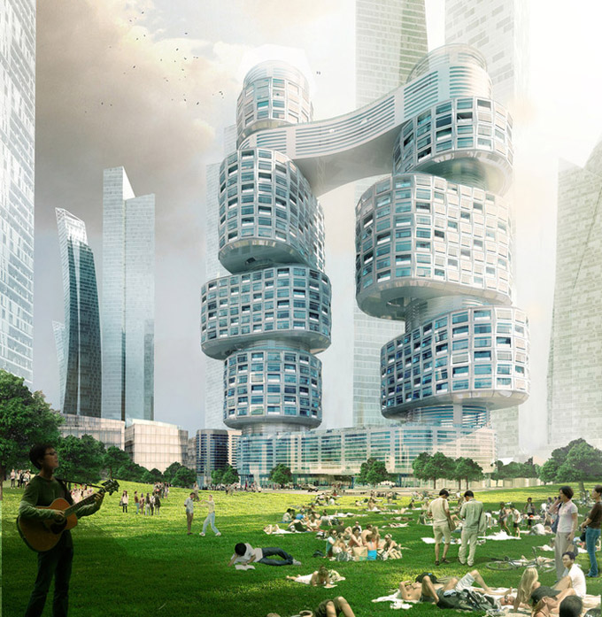
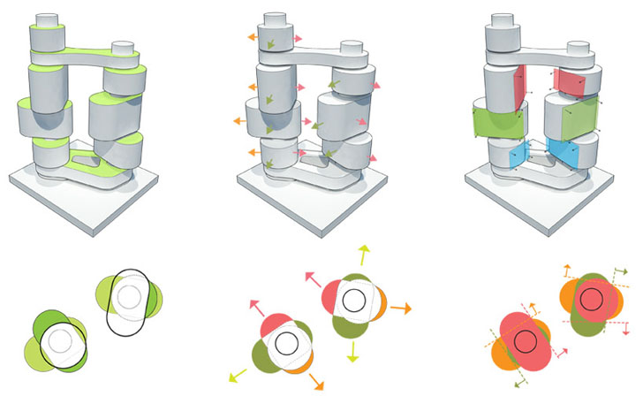
Velo Towers

Asymptote Architecture‘s round, offset Velo Towers offer an interesting alternative to typical skyscraper designs, resembling rotating parts on a machine. Both the interior residential units and external facades have been designed to be built using prefabricated parts. The skybridge, which is located 30 stories above ground, will contain common amenities, including fitness and recreation facilities, lounges, and a landscaped garden.

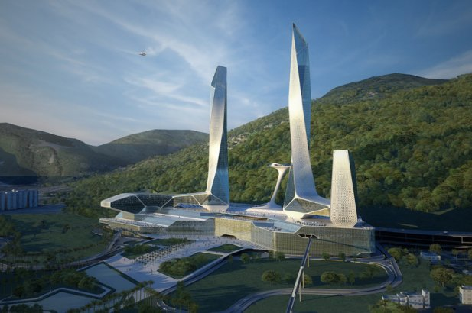
Penang Global City Center
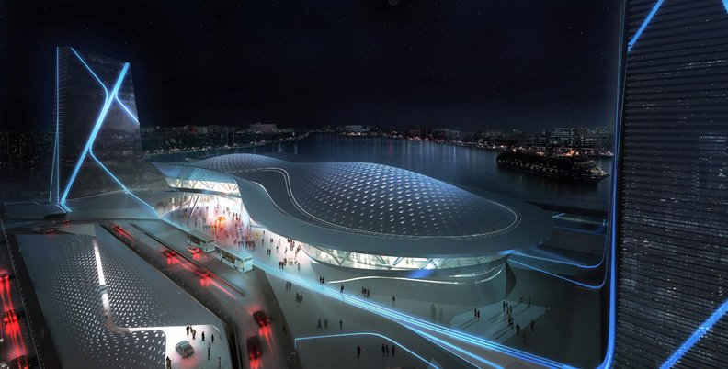
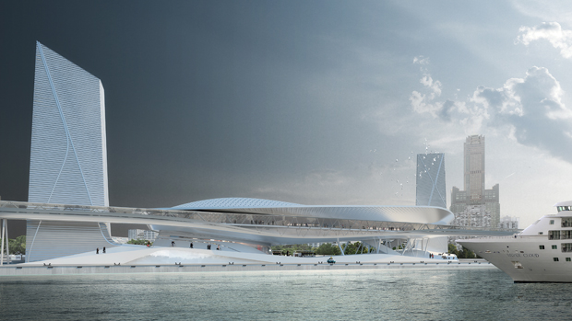

Kaohsiung Marine Gateway
The new Kaohsiung Marine Gateway Terminal designed by Asymptote is a new state of the art transportation interchange, an urban destination with both terminal and public facilities including exhibition and event spaces for the people of Kaohsiung as well as for national and international visitors. The project transforms the site from its industrial roots into a dynamic urban hub and a global gateway that bring a powerful and electric experience to the city 24 hours a day.

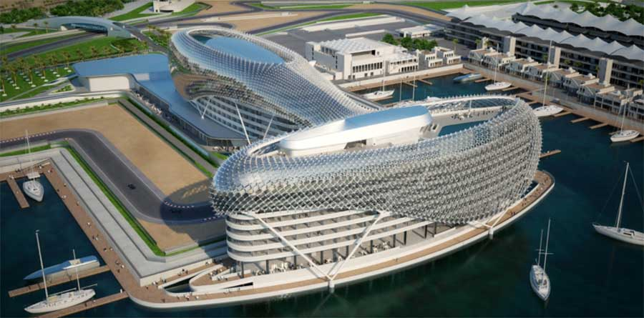
Yas Hotel

2.2.1 Installations & Exhibitions

For nearly two decades, Hani Rashid and Lise Anne Couture have also produced experimental art installations and exhibition design work involving multi-media technologies such as the Virtual Museum at the Solomon R. Guggenheim Museum in New York City

DOCUMENTA XI in Kassel, Germany; the Schirn Kunsthalle Frankfurt and the Ministry of Public Works in Madrid, Spain. In 2003, Asymptote held its first extensive solo show, a survey of it's work at the Netherlands Architecture Institute (NAI)

In 2000 Hani Rashid co-represented the United States at the Seventh Venice Biennale of Architecture, and in 2004 both Rashid and Couture were chosen as the design architects for Metamorph, the Ninth Venice Architecture Biennale. Asymptote has also produced design work, brand identities and product design for Alessi Italy, Volkswagen Wolfsberg Germany and Carlos Miele Brazil. The work of Asymptote is also included in several private and public collections including The Museum of Modern Art in New York, the Pinakothek der Moderne in Munich, the San Francisco Museum of Modern Art (SFMOMA), the Centre Georges Pompidou in Paris, and the Frac Centre in Orléans, France.

2.2.2 Awards

- Middle East Architect Awards, Hospitality Project of the Year, The Yas Hotel (2011)
- Travel + Leisure Design Awards, Best Large Hotel, The Yas Hotel (2010)
- Grand Prix de l'Architecture, Festival Automobile International (2010)
- IESNA Illumination Award (2010)
- Le Grand Prix de l’Architecture, FAI, Paris, The Yas Hotel (2010)
- American Architecture Award, Chicago Athenaeum Museum of Architecture and Design (2008)
- AIA NY Chapter Design Award, Interior Architecture (2007)
- AIA New York Chapter Design Award, Interior Architecture (2005)
- Frederick Kiesler Prize for Architecture and the Arts (2004)
- AIA New York Chapter Design Award, Architecture (2002)

